# Assignment -3

Cloud Object Storage and Watson Assistant

|  |  |
| --- | --- |
| Assignment Date | 30 October 2022 |
| Student Name | R.Mukesh kanna |
| Student Roll Number | 921319104121 |
| Maximum Marks | 2 Marks |

# Question-1:

Create a Bucket in IBM object storage

# Solution:

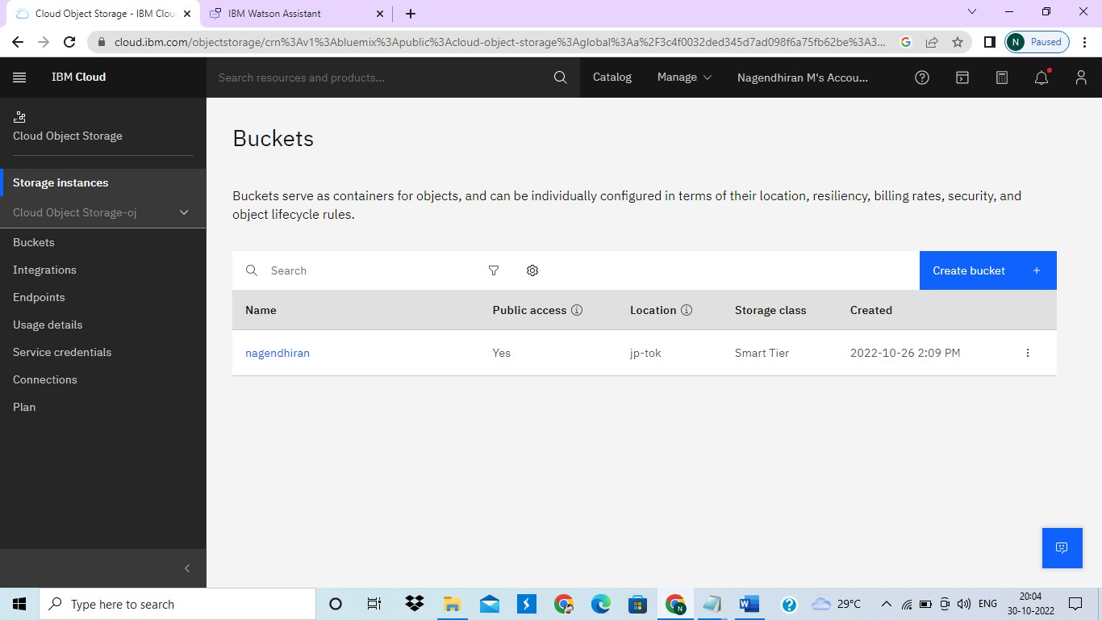

**Question-2:**

Upload an 5 images to ibm object storage and make it public. write html code to displaying all the 5 images.

**Solution:**

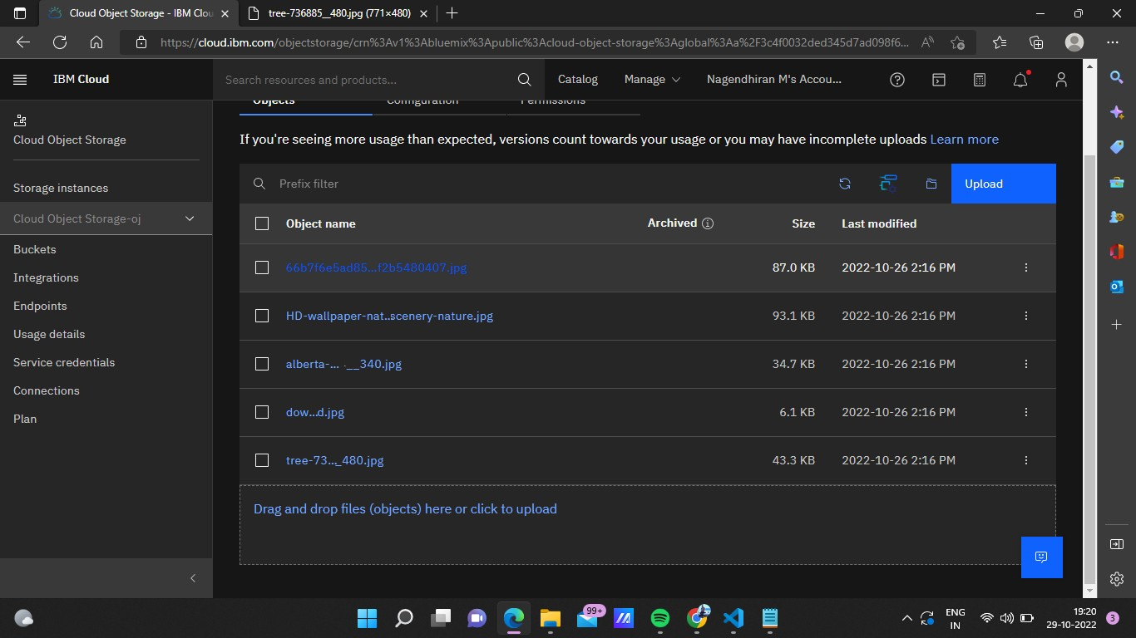

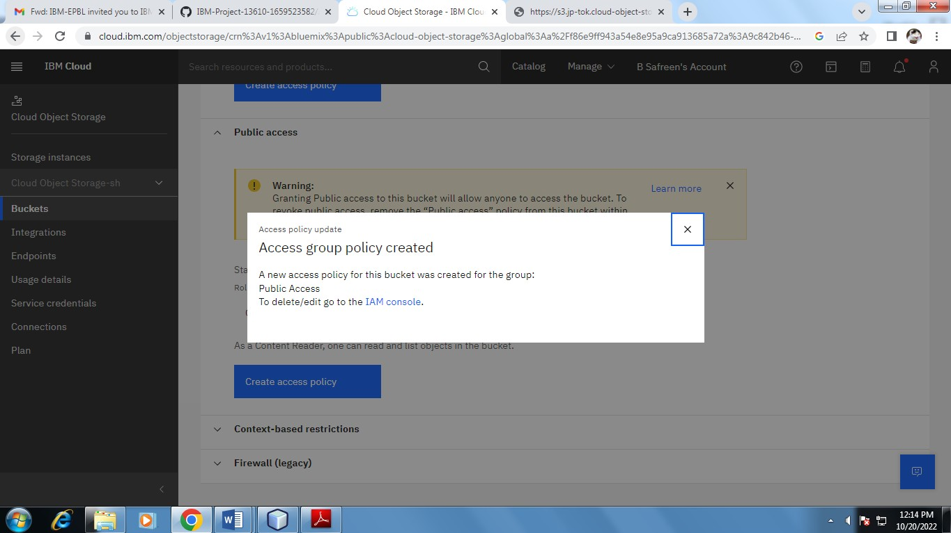

<!DOCTYPE html>

<html>

<head>

<link rel="stylesheet" href="style.css">

<title>Ass3</title>

</head>

<body>

<div class="container">

<center><h1>Images</h1></center><br><br>

<img src =

"[http://s3.jp-tok.cloud-object-](http://s3.jp-tok.cloud-object-storage.appdomain.cloud/nagendhiran/66b7f6e5ad85cdfeab3459f2b5480407.jpg) [storage.appdomain.cloud/nagendhiran/66b7f6e5ad85cdfeab3459f2b5480407.jpg](http://s3.jp-tok.cloud-object-storage.appdomain.cloud/nagendhiran/66b7f6e5ad85cdfeab3459f2b5480407.jpg)" alt = "hp" height = "250" width = "220" />

<img src =

"[http://s3.jp-tok.cloud-object-storage.appdomain.cloud/nagendhiran/HD-wallpaper-nature-](http://s3.jp-tok.cloud-object-storage.appdomain.cloud/nagendhiran/HD-wallpaper-nature-scenery-scenery-nature.jpg) [scenery-scenery-nature.jpg](http://s3.jp-tok.cloud-object-storage.appdomain.cloud/nagendhiran/HD-wallpaper-nature-scenery-scenery-nature.jpg)"

alt = "hp 1" height = "250" width = "220" />

<img src =

"[http://s3.jp-tok.cloud-object-storage.appdomain.cloud/nagendhiran/alberta-](http://s3.jp-tok.cloud-object-storage.appdomain.cloud/nagendhiran/alberta-2297204__340.jpg) [2297204 340.jpg](http://s3.jp-tok.cloud-object-storage.appdomain.cloud/nagendhiran/alberta-2297204__340.jpg)"

alt = "hp 2" height = "250" width = "220" />

<img src =

"<http://s3.jp-tok.cloud-object-storage.appdomain.cloud/nagendhiran/download.jpg>" alt = "hp 3" height = "250" width = "220" />

<img src =

"[http://s3.jp-tok.cloud-object-storage.appdomain.cloud/nagendhiran/tree-736885 480.jpg](http://s3.jp-tok.cloud-object-storage.appdomain.cloud/nagendhiran/tree-736885__480.jpg)" alt = "hp 4" height = "250" width = "220" />

</div>

</body>

</html>

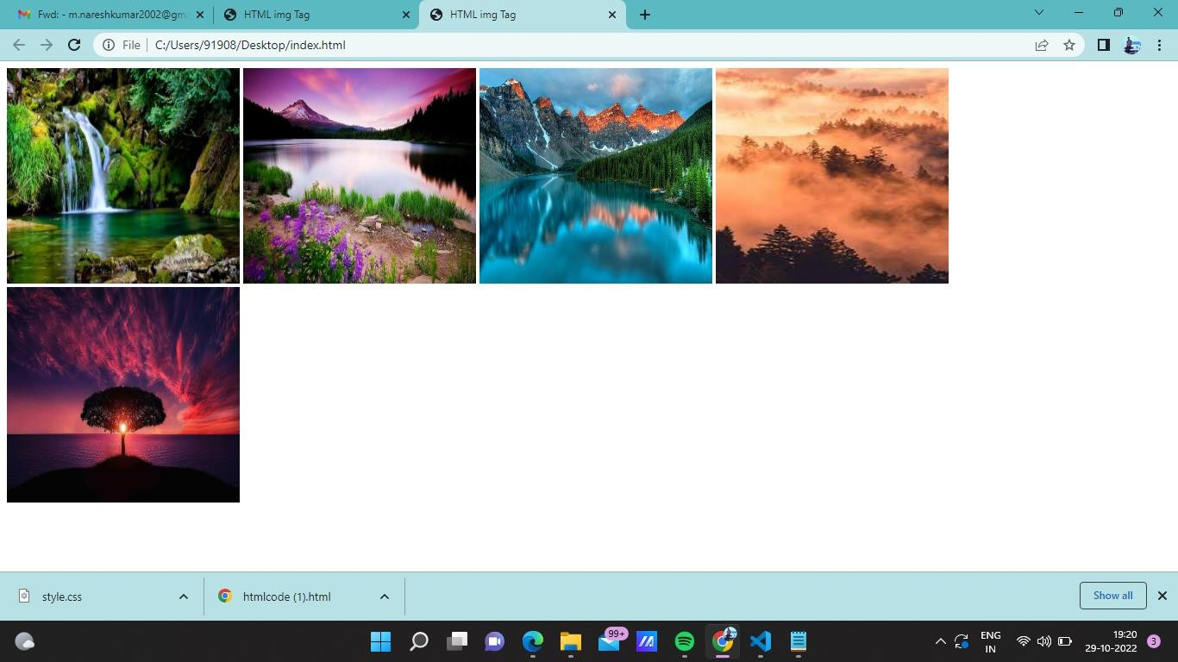

# Question-3:

Upload a css page to the object storage and use the same page in your HTML code.

# Solution:

**Uploaded style.css in object storage and used same page in html code**

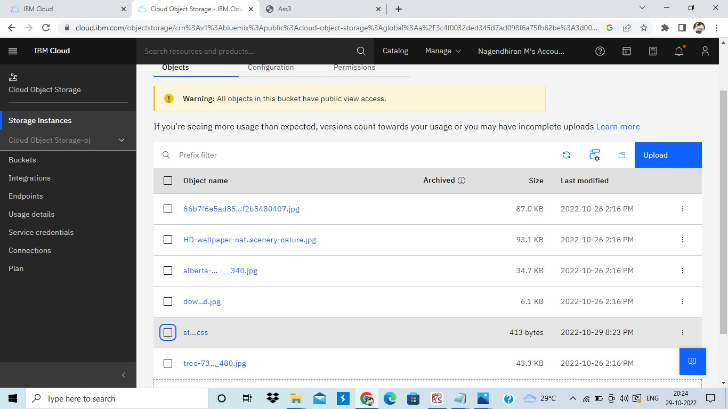

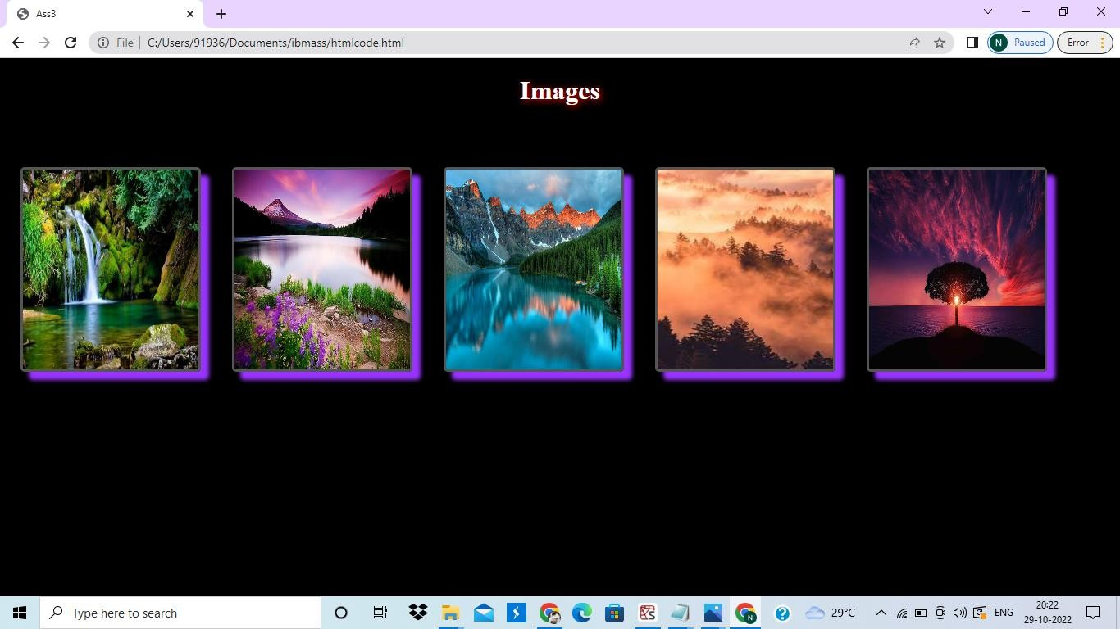

# Question-4:

Design a chatbot using IBM Watson assistant for hospital. Ex: User comes with query to know the branches for that hospital in your city. Submit the web URL of that chat bot as a assignment.

# Solution:

**URL:** [**https://web-**](https://web-chat.global.assistant.watson.appdomain.cloud/preview.html?backgroundImageURL=https%3A%2F%2Fau-syd.assistant.watson.cloud.ibm.com%2Fpublic%2Fimages%2Fupx-b5d3e666-70a2-4238-9663-2e5ab4ea3154%3A%3A32672fbe-ee65-45aa-982b-7c884be06c95&integrationID=301ecc6c-cac5-49f9-8fb7-a746a05e7507&region=au-syd&serviceInstanceID=b5d3e666-70a2-4238-9663-2e5ab4ea3154)[**chat.global.assistant.watson.appdomain.cloud/preview.html?backgroundImageURL=https%3A%2**](https://web-chat.global.assistant.watson.appdomain.cloud/preview.html?backgroundImageURL=https%3A%2F%2Fau-syd.assistant.watson.cloud.ibm.com%2Fpublic%2Fimages%2Fupx-b5d3e666-70a2-4238-9663-2e5ab4ea3154%3A%3A32672fbe-ee65-45aa-982b-7c884be06c95&integrationID=301ecc6c-cac5-49f9-8fb7-a746a05e7507&region=au-syd&serviceInstanceID=b5d3e666-70a2-4238-9663-2e5ab4ea3154)[**F%2Fau-syd.assistant.watson.cloud.ibm.com%2Fpublic%2Fimages%2Fupx-b5d3e666-70a2-4238-**](https://web-chat.global.assistant.watson.appdomain.cloud/preview.html?backgroundImageURL=https%3A%2F%2Fau-syd.assistant.watson.cloud.ibm.com%2Fpublic%2Fimages%2Fupx-b5d3e666-70a2-4238-9663-2e5ab4ea3154%3A%3A32672fbe-ee65-45aa-982b-7c884be06c95&integrationID=301ecc6c-cac5-49f9-8fb7-a746a05e7507&region=au-syd&serviceInstanceID=b5d3e666-70a2-4238-9663-2e5ab4ea3154)[**9663-2e5ab4ea3154%3A%3A32672fbe-ee65-45aa-982b-7c884be06c95&integrationID=301ecc6c-**](https://web-chat.global.assistant.watson.appdomain.cloud/preview.html?backgroundImageURL=https%3A%2F%2Fau-syd.assistant.watson.cloud.ibm.com%2Fpublic%2Fimages%2Fupx-b5d3e666-70a2-4238-9663-2e5ab4ea3154%3A%3A32672fbe-ee65-45aa-982b-7c884be06c95&integrationID=301ecc6c-cac5-49f9-8fb7-a746a05e7507&region=au-syd&serviceInstanceID=b5d3e666-70a2-4238-9663-2e5ab4ea3154)

# [cac5-49f9-8fb7-a746a05e7507&region=au-syd&serviceInstanceID=b5d3e666-70a2-4238-9663-](https://web-chat.global.assistant.watson.appdomain.cloud/preview.html?backgroundImageURL=https%3A%2F%2Fau-syd.assistant.watson.cloud.ibm.com%2Fpublic%2Fimages%2Fupx-b5d3e666-70a2-4238-9663-2e5ab4ea3154%3A%3A32672fbe-ee65-45aa-982b-7c884be06c95&integrationID=301ecc6c-cac5-49f9-8fb7-a746a05e7507&region=au-syd&serviceInstanceID=b5d3e666-70a2-4238-9663-2e5ab4ea3154) [2e5ab4ea3154](https://web-chat.global.assistant.watson.appdomain.cloud/preview.html?backgroundImageURL=https%3A%2F%2Fau-syd.assistant.watson.cloud.ibm.com%2Fpublic%2Fimages%2Fupx-b5d3e666-70a2-4238-9663-2e5ab4ea3154%3A%3A32672fbe-ee65-45aa-982b-7c884be06c95&integrationID=301ecc6c-cac5-49f9-8fb7-a746a05e7507&region=au-syd&serviceInstanceID=b5d3e666-70a2-4238-9663-2e5ab4ea3154)

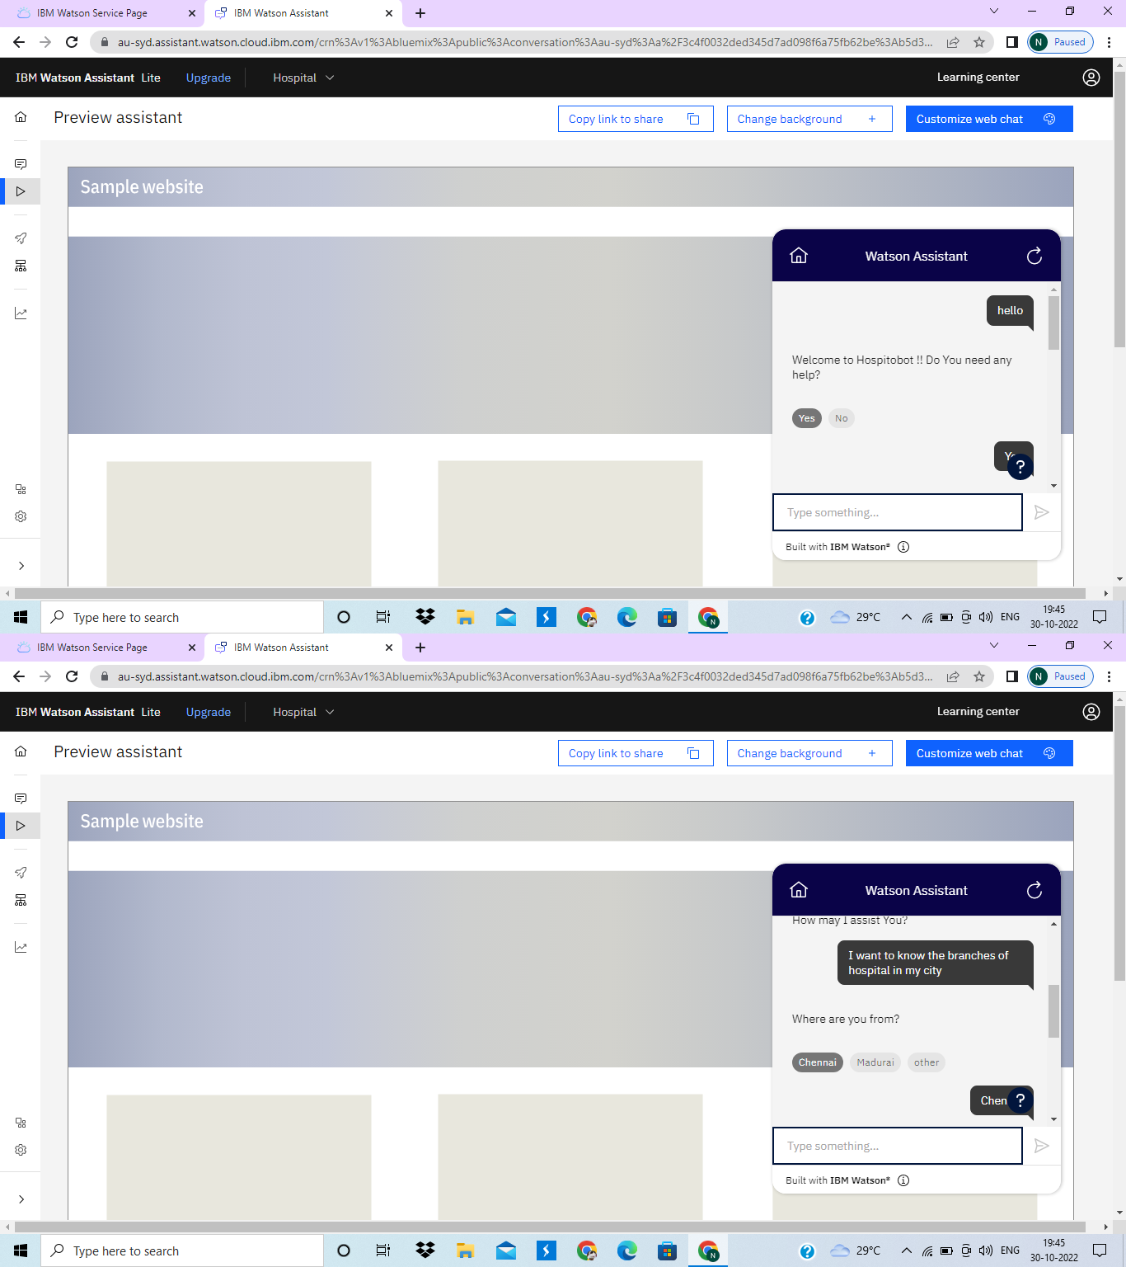

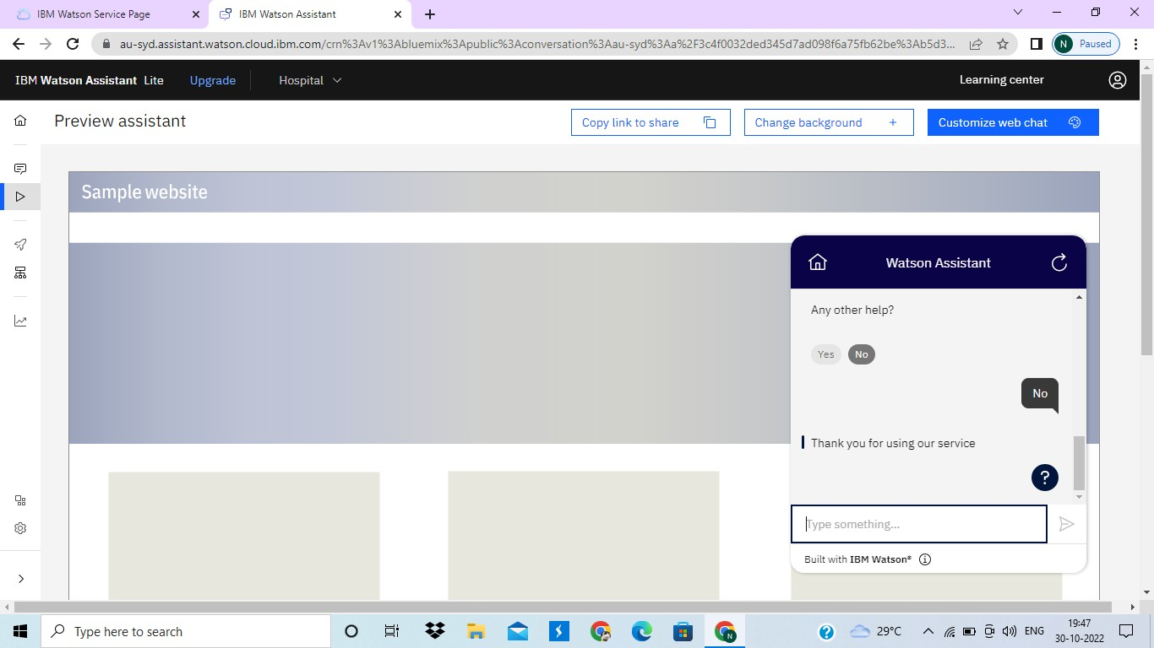

**Question-5:**

Create Watson assistant service with 10 steps and use 3 conditions in it. Load that script in HTML page.

# Solution:

<!DOCTYPE html>

<html lang="en">

<head>

<meta charset="UTF-8">

<meta http-equiv="X-UA-Compatible" content="IE=edge">

<meta name="viewport" content="width=device-width, initial-scale=1.0">

<title>N Hospital</title>

<style>

body {

font-family: Verdana, Geneva, Tahoma, sans-serif; background-color: white;

font-size: 1.7rem; color: rgb(1, 22, 74);

}

a {

color: rgb(25, 52, 0); text-decoration: none;

}

h1{

text-shadow: 2px 2px 8px #3333ff;

} a:hover {

color: rgb(0, 29, 1); padding: 5px 20px;

background-color: rgb(27, 87, 250); border-radius: 5px;

transition: .5s ease-in-out;

}

</style>

</head>

<body>

<center><br><br><br>

<h1>Naresh HOSPITAL</h1><br>

<a

href="[https://web-](https://web-chat.global.assistant.watson.appdomain.cloud/preview.html?backgroundImageURL=https%3A%2F%2Fau-syd.assistant.watson.cloud.ibm.com%2Fpublic%2Fimages%2Fupx-b5d3e666-70a2-4238-9663-2e5ab4ea3154%3A%3A32672fbe-ee65-45aa-982b-7c884be06c95&integrationID=301ecc6c-cac5-49f9-8fb7-a746a05e7507&region=au-syd&serviceInstanceID=b5d3e666-70a2-4238-9663-2e5ab4ea3154) [chat.global.assistant.watson.appdomain.cloud/preview.html?backgroundImageURL=https%3A%2F%](https://web-chat.global.assistant.watson.appdomain.cloud/preview.html?backgroundImageURL=https%3A%2F%2Fau-syd.assistant.watson.cloud.ibm.com%2Fpublic%2Fimages%2Fupx-b5d3e666-70a2-4238-9663-2e5ab4ea3154%3A%3A32672fbe-ee65-45aa-982b-7c884be06c95&integrationID=301ecc6c-cac5-49f9-8fb7-a746a05e7507&region=au-syd&serviceInstanceID=b5d3e666-70a2-4238-9663-2e5ab4ea3154) [2Fau-syd.assistant.watson.cloud.ibm.com%2Fpublic%2Fimages%2Fupx-b5d3e666-70a2-4238-9663-](https://web-chat.global.assistant.watson.appdomain.cloud/preview.html?backgroundImageURL=https%3A%2F%2Fau-syd.assistant.watson.cloud.ibm.com%2Fpublic%2Fimages%2Fupx-b5d3e666-70a2-4238-9663-2e5ab4ea3154%3A%3A32672fbe-ee65-45aa-982b-7c884be06c95&integrationID=301ecc6c-cac5-49f9-8fb7-a746a05e7507&region=au-syd&serviceInstanceID=b5d3e666-70a2-4238-9663-2e5ab4ea3154) [2e5ab4ea3154%3A%3A32672fbe-ee65-45aa-982b-7c884be06c95&integrationID=301ecc6c-cac5-](https://web-chat.global.assistant.watson.appdomain.cloud/preview.html?backgroundImageURL=https%3A%2F%2Fau-syd.assistant.watson.cloud.ibm.com%2Fpublic%2Fimages%2Fupx-b5d3e666-70a2-4238-9663-2e5ab4ea3154%3A%3A32672fbe-ee65-45aa-982b-7c884be06c95&integrationID=301ecc6c-cac5-49f9-8fb7-a746a05e7507&region=au-syd&serviceInstanceID=b5d3e666-70a2-4238-9663-2e5ab4ea3154) [49f9-8fb7-a746a05e7507&region=au-syd&serviceInstanceID=b5d3e666-70a2-4238-9663-](https://web-chat.global.assistant.watson.appdomain.cloud/preview.html?backgroundImageURL=https%3A%2F%2Fau-syd.assistant.watson.cloud.ibm.com%2Fpublic%2Fimages%2Fupx-b5d3e666-70a2-4238-9663-2e5ab4ea3154%3A%3A32672fbe-ee65-45aa-982b-7c884be06c95&integrationID=301ecc6c-cac5-49f9-8fb7-a746a05e7507&region=au-syd&serviceInstanceID=b5d3e666-70a2-4238-9663-2e5ab4ea3154) [2e5ab4ea3154](https://web-chat.global.assistant.watson.appdomain.cloud/preview.html?backgroundImageURL=https%3A%2F%2Fau-syd.assistant.watson.cloud.ibm.com%2Fpublic%2Fimages%2Fupx-b5d3e666-70a2-4238-9663-2e5ab4ea3154%3A%3A32672fbe-ee65-45aa-982b-7c884be06c95&integrationID=301ecc6c-cac5-49f9-8fb7-a746a05e7507&region=au-syd&serviceInstanceID=b5d3e666-70a2-4238-9663-2e5ab4ea3154)">

Click Here to Open Chatbot

</a>

</center>

<!-- Embedded Code From Watson Assistant -->

<script> window.watsonAssistantChatOptions = {

integrationID: "301ecc6c-cac5-49f9-8fb7-a746a05e7507", // The ID of this integration. region: "au-syd", // The region your integration is hosted in.

serviceInstanceID: "b5d3e666-70a2-4238-9663-2e5ab4ea3154", // The ID of your service instance. onLoad: function(instance) { instance.render(); }

};

setTimeout(function(){

const t=document.createElement('script');

t.src="https://web-chat.global.assistant.watson.appdomain.cloud/versions/" + (window.watsonAssistantChatOptions.clientVersion || 'latest') + "/WatsonAssistantChatEntry.js";

document.head.appendChild(t);

});

</script>

</body>

</html>

